----Some Related Quary problems ----------------

--Find the FirstNmae,and LastName whose blood group is AB-

SELECT FirstName,LastName,Age

FROM Donors

WHERE BloodGRoup='AB-'

--Find the names of donors, their blood group,Age, the names of the doctor and helper,

-- and the sub-branch name where the blood group is O+.

SELECT

d.DonorID,

d.FirstName AS DonorFirstName,

d.LastName AS DonorLastName,

d.BloodGroup AS DonorBloodGroup,

d.Age AS DonorAge,

dr.FirstName AS DoctorFirstName,

dr.LastName AS DoctorLastName,

h.FirstName AS HelperFirstName,

h.LastName AS HelperLastName,

sb.BranchName AS SubBranchName

FROM

Donors d

JOIN

Donor_Branch db ON d.DonorID = db.DonorID

JOIN

SubBranch sb ON db.SubBranchID = sb.SubBranchID

JOIN

Doctors_SubBranch dsb ON db.SubBranchID = dsb.SubBranchID

JOIN

Doctors dr ON dsb.DoctorID = dr.DoctorID

JOIN

Helpers_Doctors hd ON dr.DoctorID = hd.DoctorID

JOIN

Helpers h ON hd.HelperID = h.HelperID

WHERE

d.BloodGroup = 'O+';

--Find all donor names, ages, blood groups, and their

-- assigned doctor names along with the branch they are assigned to.

SELECT

d.FirstName AS DonorFirstName,

d.LastName AS DonorLastName,

d.Age AS DonorAge,

d.BloodGroup AS DonorBloodGroup,

dr.FirstName AS DoctorFirstName,

dr.LastName AS DoctorLastName,

sb.BranchName AS AssignedBranch

FROM

Donors d

JOIN

Donor_Branch db ON d.DonorID = db.DonorID

JOIN

SubBranch sb ON db.SubBranchID = sb.SubBranchID

JOIN

Doctors_SubBranch dsb ON db.SubBranchID = dsb.SubBranchID

JOIN

Doctors dr ON dsb.DoctorID = dr.DoctorID;

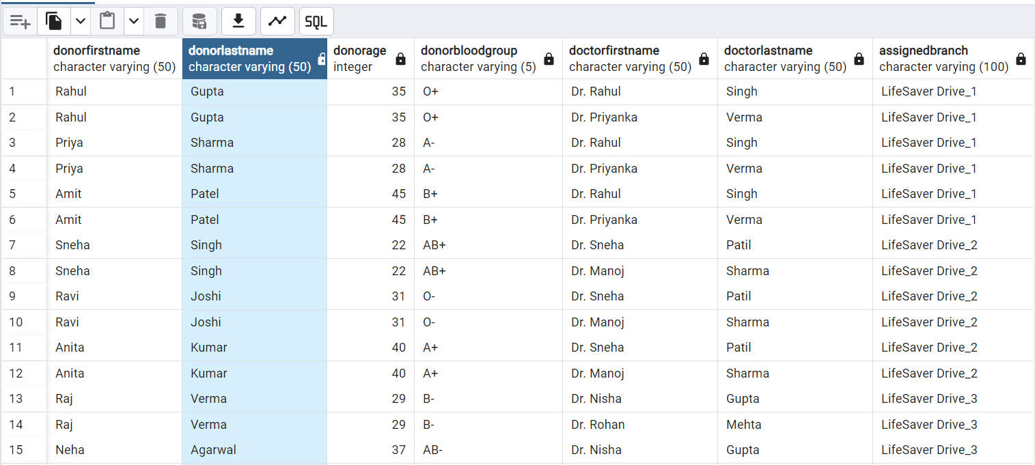

--Find Doctor FirstName,Specialization,Contactnum and their helpers,and their contactnumber in asc order

SELECT

dr.FirstName AS DoctorFirstName,

dr.Specialization,

dr.ContactNumber AS DoctorContactNumber,

h.FirstName AS HelperFirstName,

h.ContactNumber AS HelperContactNumber

FROM

Doctors AS dr

INNER JOIN

Helpers_Doctors AS hd ON dr.DoctorID = hd.DoctorID

INNER JOIN

Helpers AS h ON hd.HelperID = h.HelperID

ORDER BY

dr.FirstName ASC;

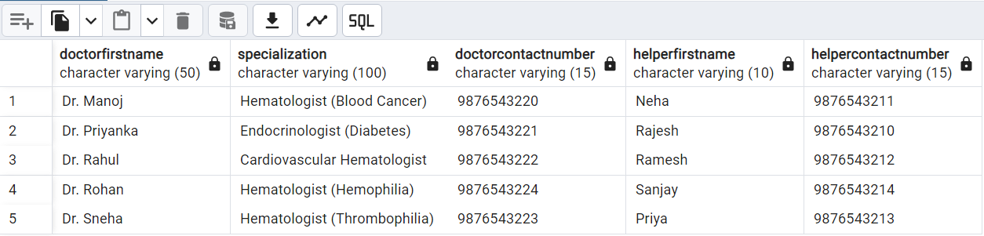

--Find the total number of donors in each blood group:

SELECT BloodGroup, COUNT(*) AS TotalDonors

FROM Donors

GROUP BY BloodGroup;

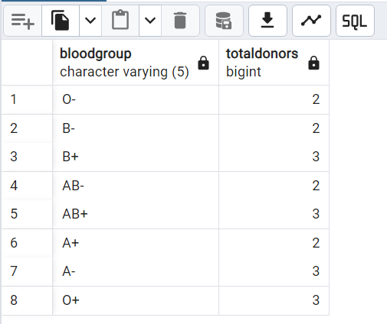

--Find the average age of donors for each blood group:

SELECT BloodGroup, AVG(Age) AS AverageAge

FROM Donors

GROUP BY BloodGroup;

--Find the sub-branches with the highest number of donors:

SELECT sb.BranchName, COUNT(*) AS TotalDonors

FROM SubBranch sb

JOIN Donor_Branch db ON sb.SubBranchID = db.SubBranchID

GROUP BY sb.BranchName

ORDER BY TotalDonors DESC;

--Find 5 max age doner name

SELECT * FROM Donors

ORDER BY DonorID DESC

limit 5;

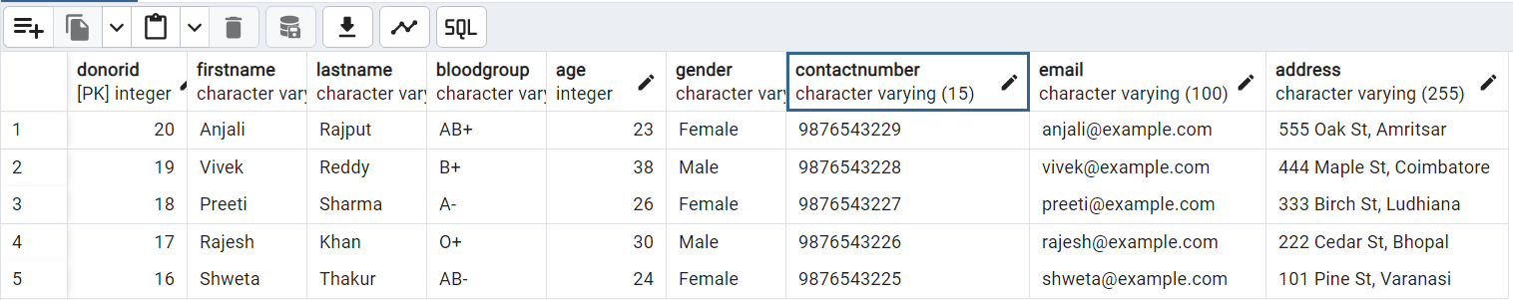

--Name and Bloodgroup who has rare blood

SELECT FirstName,LastName,BloodGroup

FROM Donors

WHERE BloodGroup NOT IN ('A+', 'B+', 'AB+', 'O+')

ORDER BY DonorID DESC;

--Retrieve SubBranches with Helper Contact Numbers in Howrah:

SELECT SubBranchID, BranchName, Location, HelperContactNumber

FROM SubBranch;

--Update Helper Contact Number for a Specific SubBranch:

UPDATE SubBranch

SET HelperContactNumber = '9876543213'

WHERE SubBranchID = 3;

--Retrieve the details of doctors along with their associated sub-branches.

SELECT

d.DoctorID,

d.FirstName AS DoctorFirstName,

d.LastName AS DoctorLastName,

d.Specialization,

sb.BranchName,

sb.Location

FROM

Doctors d

INNER JOIN

Doctors_SubBranch ds ON d.DoctorID = ds.DoctorID

INNER JOIN

SubBranch sb ON ds.SubBranchID = sb.SubBranchID;

-- List all donors along with their associated sub-branch locations

SELECT

d.FirstName AS DonorFirstName,

d.LastName AS DonorLastName,

d.BloodGroup,

sb.Location

FROM

Donors d

INNER JOIN

Donor_Branch db ON d.DonorID = db.DonorID

INNER JOIN

SubBranch sb ON db.SubBranchID = sb.SubBranchID;

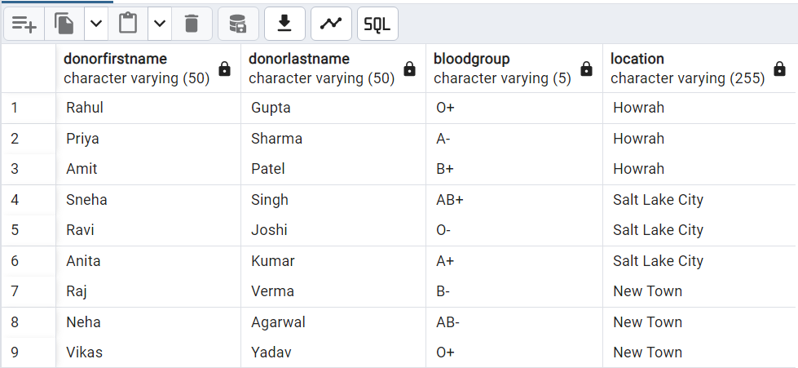

-- To find donors with a specific name pattern using LIKE:

SELECT

DonorID,

FirstName,

LastName,

BloodGroup,

Age

FROM

Donors

WHERE

FirstName LIKE 'A%'; -- Finds donors whose first name starts with 'A'

-- To find donors within a certain age range using BETWEEN:

SELECT

DonorID,

FirstName,

LastName,

BloodGroup,

Age

FROM

Donors

WHERE

Age BETWEEN 25 AND 30; -- Finds donors whose age is between 18 and 30

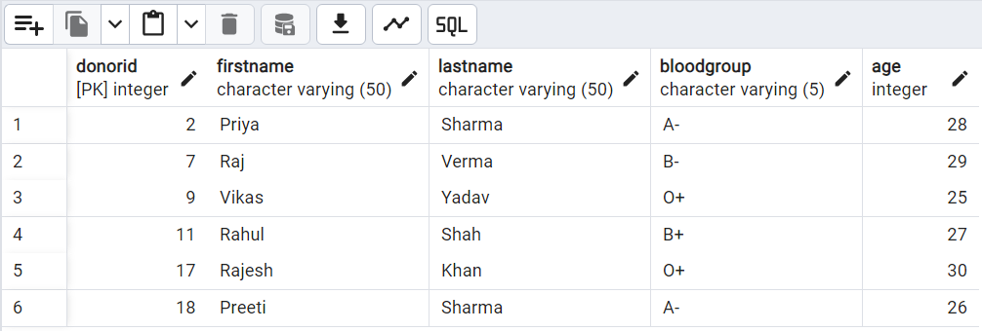

-- To find donors with specific blood groups using IN:

SELECT

DonorID,

FirstName,

LastName,

BloodGroup,

Age

FROM

Donors

WHERE

BloodGroup IN ('O+', 'A+', 'B+'); -- Finds donors with blood groups O+, A+, or B+

-- To find doctors with a specific specialization using LIKE:

SELECT

DoctorID,

FirstName,

LastName,

Specialization,

ContactNumber

FROM

Doctors

WHERE

Specialization LIKE '%Endocrinologist%'; -- Finds doctors with 'Endocrinologist' in their specialization

*** The End ***